Tangent–Secant Theorem
# Source: AI Source: Provided by: [Data Path: Persons Table -> ID Column: 1, Name_En Column: Motasem Essam] -> From: [ChatGPT] on [7/25/2026]
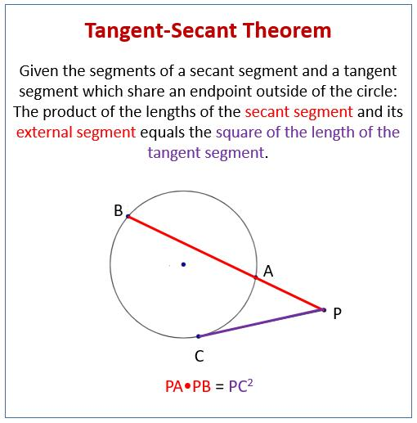
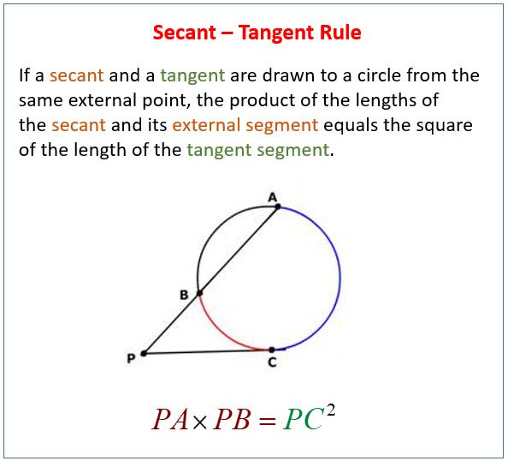
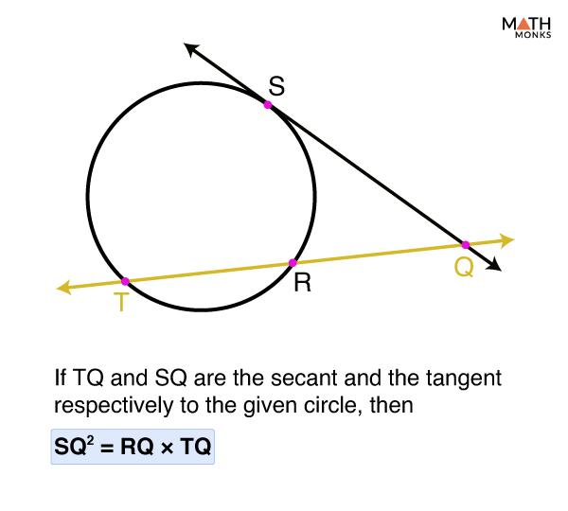

Definition
# Source: AI Source: Provided by: [Data Path: Persons Table -> ID Column: 1, Name_En Column: Motasem Essam] -> From: [ChatGPT] on [7/25/2026]
The Tangent–Secant Theorem describes the relationship between a tangent segment and a secant segment drawn from the same external point to a circle.
If:
- $PT$is tangent to a circle at $T$,
- $PAB$is a secant through the same external point $P$,
- $A$is the nearer intersection point,
- $B$is the farther intersection point,
then:
$$\boxed{PT^{2}=PA⋅PB}$$
In words:
The square of the tangent segment equals the product of the external part and the entire secant segment.

Fundamental Concept
# Source: AI Source: Provided by: [Data Path: Persons Table -> ID Column: 1, Name_En Column: Motasem Essam] -> From: [ChatGPT] on [7/25/2026]
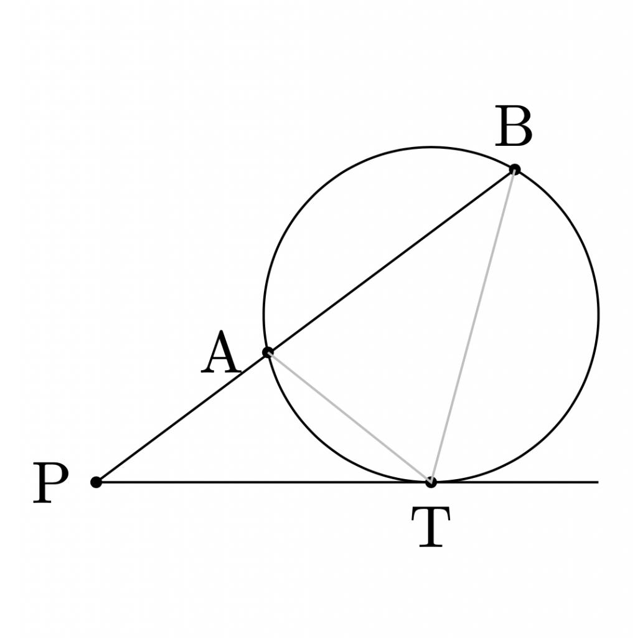
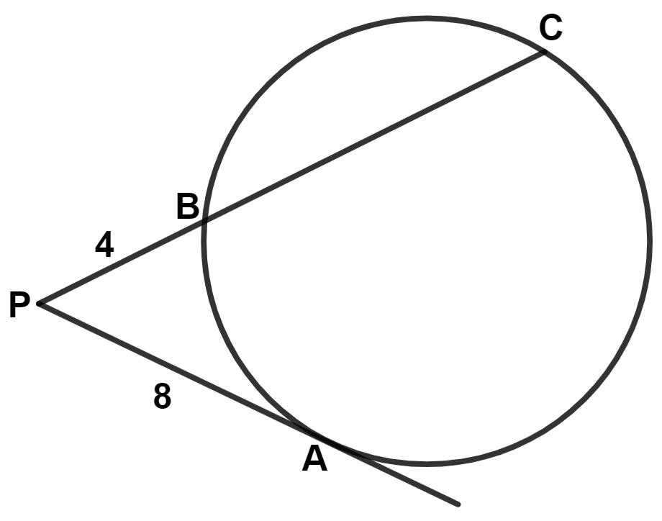
Consider an external point $P$.
From $P$:
- $PT$touches the circle at $T$.
- A secant passes through the circle at $A$and $B$.
Then:
$$\boxed{PT^{2}=PA⋅PB}$$
where:
$$PA=\text{external secant segment}$$
and
$$PB=\text{entire secant segment}.$$

Main Parts
# Source: AI Source: Provided by: [Data Path: Persons Table -> ID Column: 1, Name_En Column: Motasem Essam] -> From: [ChatGPT] on [7/25/2026]
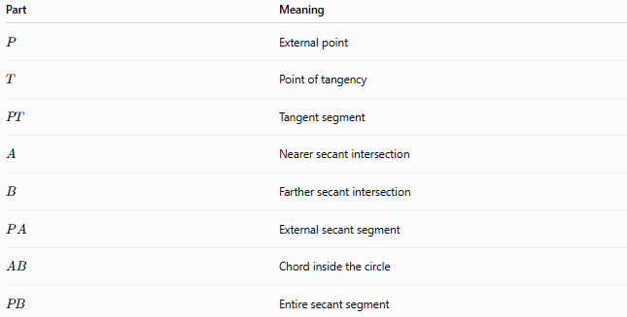
Part | Meaning
$$P$$ | External point
$$T$$ | Point of tangency
$$PT$$ | Tangent segment
$$A$$ | Nearer secant intersection
$$B$$ | Farther secant intersection
$$PA$$ | External secant segment
$$AB$$ | Chord inside the circle
$$PB$$ | Entire secant segment
The central relationship is:
$$\boxed{PT^{2}=PA⋅PB}$$

Theorem Statement
# Source: AI Source: Provided by: [Data Path: Persons Table -> ID Column: 1, Name_En Column: Motasem Essam] -> From: [ChatGPT] on [7/25/2026]
If two lines from an external point $P$meet a circle, with one line tangent to the circle and the other a secant, then:
$$\boxed{{\left(\text{tangent}\right)}^{2}=\left(\text{external secant}\right)\left(\text{whole secant}\right)}$$
Therefore:
$$\boxed{PT^{2}=PA⋅PB}$$

Example 1 — Finding the Tangent Length
# Source: AI Source: Provided by: [Data Path: Persons Table -> ID Column: 1, Name_En Column: Motasem Essam] -> From: [ChatGPT] on [7/25/2026]
Suppose:
$$PA=9$$
and:
$$PB=25$$
Then:
$$PT^{2}=PA⋅PB \\ PT^{2}=9\left(25\right) \\ PT^{2}=225$$
Therefore:
$$\boxed{PT=15}$$

Example 2 — Finding the Entire Secant
# Source: AI Source: Provided by: [Data Path: Persons Table -> ID Column: 1, Name_En Column: Motasem Essam] -> From: [ChatGPT] on [7/25/2026]
Suppose:
$$PT=12$$
and:
$$PA=8$$
Using:
$$PT^{2}=PA⋅PB$$
we get:
$${12}^{2}=8\left(PB\right) \\ 144=8\left(PB\right) \\ \boxed{PB=18}$$

Example 3 — Finding the External Segment
# Source: AI Source: Provided by: [Data Path: Persons Table -> ID Column: 1, Name_En Column: Motasem Essam] -> From: [ChatGPT] on [7/25/2026]
Suppose:
$$PT=10$$
and:
$$PB=20$$
Then:
$$PT^{2}=PA⋅PB \\ 100=PA\left(20\right)$$
Therefore:
$$\boxed{PA=5}$$

Secant Segment Relationship
# Source: AI Source: Provided by: [Data Path: Persons Table -> ID Column: 1, Name_En Column: Motasem Essam] -> From: [ChatGPT] on [7/25/2026]
The entire secant consists of the external segment plus the chord inside the circle:
$$\boxed{PB=PA+AB}$$
Therefore, the theorem can also be written as:
$$\boxed{PT^{2}=PA\left(PA+AB\right)}$$
This form is useful when the external portion and the chord length are given.
Example
Suppose:
$$PA=6, AB=10$$
Then:
$$PB=6+10=16$$
Therefore:
$$PT^{2}=6\left(16\right)=96$$
So:
$$\boxed{PT=4\sqrt{6}}$$

Relationship with Power of a Point
# Source: AI Source: Provided by: [Data Path: Persons Table -> ID Column: 1, Name_En Column: Motasem Essam] -> From: [ChatGPT] on [7/25/2026]
The Tangent–Secant Theorem is a direct application of the Power of a Point.
For an external point $P$:
$$Pow⁡\left(P\right)=PT^{2}$$
because $PT$is tangent.
The same power can be calculated using a secant:
$$Pow⁡\left(P\right)=PA⋅PB$$
Therefore:
$$\boxed{PT^{2}=PA⋅PB}$$
So:
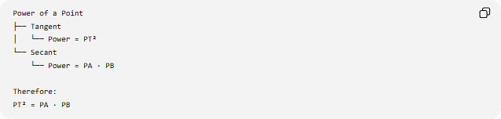
Power of a Point
├── Tangent
│ └── Power = PT²
└── Secant
└── Power = PA · PB

Therefore:
PT² = PA · PB

Relationship with the Tangent Segments Theorem
# Source: AI Source: Provided by: [Data Path: Persons Table -> ID Column: 1, Name_En Column: Motasem Essam] -> From: [ChatGPT] on [7/25/2026]
If two tangents are drawn from the same external point $P$:
$$PA=PB$$
Then:
$$PA^{2}=PB^{2}$$
This is a different theorem from the Tangent–Secant Theorem.
Theorem | Formula
Tangent Segments Theorem | $$PA=PB$$
Tangent–Secant Theorem | $$PT^{2}=PA⋅PB$$
The first compares two tangent segments.
The second compares one tangent segment with a secant.

Relationship with the Secant–Secant Theorem
# Source: AI Source: Provided by: [Data Path: Persons Table -> ID Column: 1, Name_En Column: Motasem Essam] -> From: [ChatGPT] on [7/25/2026]
The Tangent–Secant Theorem is closely related to the Secant–Secant Theorem.
Tangent–Secant
$$\boxed{PT^{2}=PA⋅PB}$$
Secant–Secant
If two secants from $P$intersect the circle at $A,B$and $C,D$:
$$\boxed{PA⋅PB=PC⋅PD}$$
Both express the same fundamental quantity:
$$\boxed{Power⁡\left(P\right)}$$

Geometric Interpretation
# Source: AI Source: Provided by: [Data Path: Persons Table -> ID Column: 1, Name_En Column: Motasem Essam] -> From: [ChatGPT] on [7/25/2026]
The theorem can be understood as a balance between the tangent and secant lengths.
The tangent length is not simply equal to either secant portion.
Instead:
$$PT=\sqrt{PA⋅PB}$$
Thus, the tangent length is the geometric mean of the external and entire secant lengths.
$$\boxed{PT=\sqrt{PA⋅PB}}$$

Proof of the Theorem
# Source: AI Source: Provided by: [Data Path: Persons Table -> ID Column: 1, Name_En Column: Motasem Essam] -> From: [ChatGPT] on [7/25/2026]
The theorem can be proved using similar triangles.
Let:
- $PT$be tangent to the circle at $T$,
- $PAB$be a secant,
- $C$be another point on the circle chosen so that the relevant angles correspond.
By the tangent–chord relationship and the inscribed-angle relationships, the appropriate triangles formed by $P,T,A,B$are similar.
From similarity, the corresponding sides give:
$$\frac{PT}{PA}=\frac{PB}{PT}$$
Cross-multiplying:
$$PT^{2}=PA⋅PB$$
Therefore:
$$\boxed{PT^{2}=PA⋅PB}$$

Coordinate / Circle Formula
# Source: AI Source: Provided by: [Data Path: Persons Table -> ID Column: 1, Name_En Column: Motasem Essam] -> From: [ChatGPT] on [7/25/2026]
For a circle with center $O$and radius $r$, if $P$is outside the circle:
$$\boxed{PT=\sqrt{PO^{2}-r^{2}}}$$
Squaring:
$$PT^{2}=PO^{2}-r^{2}$$
This is exactly the power of $P$.
Therefore:
$$\boxed{PA⋅PB=PO^{2}-r^{2}}$$
and:
$$\boxed{PT^{2}=PA⋅PB=PO^{2}-r^{2}}$$

Example Using the Center

Suppose:
$$PO=13$$
and:
$$r=5$$
The tangent length is:
$$PT=\sqrt{{13}^{2}-5^{2}} \\ PT=\sqrt{169-25} \\ PT=\sqrt{144} \\ \boxed{PT=12}$$
Therefore:
$$\boxed{PT^{2}=144}$$
Any secant from $P$must therefore satisfy:
$$\boxed{PA⋅PB=144}$$

Important Conditions
# Source: AI Source: Provided by: [Data Path: Persons Table -> ID Column: 1, Name_En Column: Motasem Essam] -> From: [ChatGPT] on [7/25/2026]
The theorem requires:
- $P$is outside the circle.
- $PT$is tangent to the circle.
- $PAB$is a secant.
- $A$is the nearer intersection.
- $B$is the farther intersection.
Thus:
$$P-A-B$$
and:
$$\boxed{PB=PA+AB}$$

Special Cases

A. Tangent Length Equals the Geometric Mean
# Source: AI Source: Provided by: [Data Path: Persons Table -> ID Column: 1, Name_En Column: Motasem Essam] -> From: [ChatGPT] on [7/25/2026]
$$\boxed{PT=\sqrt{PA⋅PB}}$$
So $PT$is the geometric mean of $PA$and $PB$.

B. Secant Through the Center
# Source: AI Source: Provided by: [Data Path: Persons Table -> ID Column: 1, Name_En Column: Motasem Essam] -> From: [ChatGPT] on [7/25/2026]
If the secant passes through the center, the chord $AB$is a diameter.
If the circle has radius $r$, then:
$$AB=2r$$
and:
$$PB=PA+2r$$
Therefore:
$$\boxed{PT^{2}=PA\left(PA+2r\right)}$$

C. Two Tangents Instead of a Secant
# Source: AI Source: Provided by: [Data Path: Persons Table -> ID Column: 1, Name_En Column: Motasem Essam] -> From: [ChatGPT] on [7/25/2026]
If the second line is also tangent, the relationship changes to:
$$\boxed{PT=PQ}$$
for tangent points $T$and $Q$.
This is the Tangent Segments Theorem.

Classification
# Source: AI Source: Provided by: [Data Path: Persons Table -> ID Column: 1, Name_En Column: Motasem Essam] -> From: [ChatGPT] on [7/25/2026]
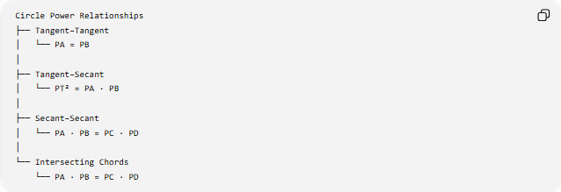
Circle Power Relationships
├── Tangent–Tangent
│ └── PA = PB
│
├── Tangent–Secant
│ └── PT² = PA · PB
│
├── Secant–Secant
│ └── PA · PB = PC · PD
│
└── Intersecting Chords
└── PA · PB = PC · PD

Comparison with Related Circle Theorems
# Source: AI Source: Provided by: [Data Path: Persons Table -> ID Column: 1, Name_En Column: Motasem Essam] -> From: [ChatGPT] on [7/25/2026]
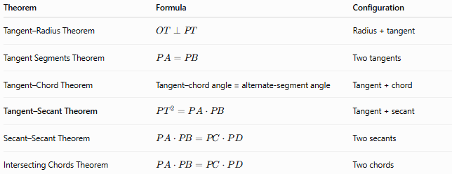
Theorem | Formula | Configuration
Tangent–Radius Theorem | $$OT⊥PT$$ | Radius + tangent
Tangent Segments Theorem | $$PA=PB$$ | Two tangents
Tangent–Chord Theorem | Tangent–chord angle = alternate-segment angle | Tangent + chord
Tangent–Secant Theorem | $$PT^{2}=PA⋅PB$$ | Tangent + secant
Secant–Secant Theorem | $$PA⋅PB=PC⋅PD$$ | Two secants
Intersecting Chords Theorem | $$PA⋅PB=PC⋅PD$$ | Two chords

Key Formulas
# Source: AI Source: Provided by: [Data Path: Persons Table -> ID Column: 1, Name_En Column: Motasem Essam] -> From: [ChatGPT] on [7/25/2026]
Main theorem
$$\boxed{PT^{2}=PA⋅PB}$$
Tangent length
$$\boxed{PT=\sqrt{PA⋅PB}}$$
Entire secant
$$\boxed{PB=\frac{PT^{2}}{PA}}$$
External secant
$$\boxed{PA=\frac{PT^{2}}{PB}}$$
Entire secant in terms of the chord
$$\boxed{PB=PA+AB}$$
Therefore:
$$\boxed{PT^{2}=PA\left(PA+AB\right)}$$
Power of a point
$$\boxed{Pow⁡\left(P\right)=PT^{2}=PA⋅PB}$$

Key Points
# Source: AI Source: Provided by: [Data Path: Persons Table -> ID Column: 1, Name_En Column: Motasem Essam] -> From: [ChatGPT] on [7/25/2026]
- The theorem applies to a tangent and a secant drawn from the same external point.
- The tangent segment is squared.
- The secant uses the external segment × entire secant segment.
- The fundamental formula is:
$$\boxed{PT^{2}=PA⋅PB}$$
- The tangent length is the geometric mean:
$$\boxed{PT=\sqrt{PA⋅PB}}$$
- The theorem is a direct application of the Power of a Point.
- If the secant passes through the center, its internal chord is a diameter.
- The theorem is closely related to the Secant–Secant and Tangent–Tangent relationships.

Conclusion
# Source: AI Source: Provided by: [Data Path: Persons Table -> ID Column: 1, Name_En Column: Motasem Essam] -> From: [ChatGPT] on [7/25/2026]
The Tangent–Secant Theorem establishes the fundamental relationship:
$$\boxed{{\text{Tangent}}^{2}=\text{External Secant}×\text{Entire Secant}}$$
or:
$$\boxed{PT^{2}=PA⋅PB}$$
Together with the Tangent–Radius, Tangent–Chord, Tangent Segments, and Secant–Secant theorems, it forms an important group of circle power and tangency theorems.

